Business case

The purpose of this document is to outline how the proposed system solves a real-world problem, project objectives, risk analysis as well as related systems analysis, and the overall project plan – including scope and deliverables.

**1.1 Optimising GBV Incident Reporting**

Gender-Based Violence (GBV) is a prevalent and growing concern in South Africa. South Africa has one of the highest rates of GBV in the world, with daily reports of attacks, harassment, and femicide making the news and showing up in national statistics. People of all ages, genders, and economic standings are victim to this crime, creating a major human rights crisis and societal worry.

A crucial issue in addressing GBV situations is the process of reporting. There is usually either a fear of safety due to the lack of anonymity, a fear of stigma due to societal judgement, mistrust in the existing aid available for victims, or limited access to accessible avenues. In under-resourced areas, they are faced with issues such as lack of responsive and instantaneous support services or having police stations distanced far away from them.  
  
The result of this is under-reported GBV cases, leaving victims feeling silenced as well as preventing support services such as police and NGOs from responding effectively. Due to the lack of reliable reporting channels, data on GBV instances are inadequate, preventing the ability for organizations to design interventions, allocate resources properly, and protect vulnerable groups.

**1.2 Project objectives**

The GBV Reporting App aims to address critical real-world problems in South Africa’s gender-based violence (GBV) reporting and support system. Below are the key objectives of the software intervention:

**1. Enable Anonymous & Secure Reporting**

Problem: Many survivors fear retaliation, stigma, or distrust authorities, leading to underreporting.

Solution:

- Provide end-to-end encrypted, anonymous reporting to protect user identities.

- Offer a stealth mode (disguised app icon) for safety.

**2. Improve Accessibility of Reporting**

Problem: Physical reporting (police stations, helplines) is often unsafe, distant, or unavailable.

Solution:

- Mobile-first platform for real-time incident reporting anytime, anywhere.

- Offline-first capability (store reports if no internet, sync later).

**3. Enhance Emergency Response with Location Data**

Problem: GBV hotspots are poorly mapped, delaying interventions.

Solution:

- GPS tagging of incidents to identify high-risk areas in real time.

- Automated alerts to nearby NGOs/police (if user consents).

**4. Bridge the Gap to Support Services**

Problem: Survivors struggle to find shelters, legal aid, or medical help quickly.

Solution:

- Integrated directory of verified support services (NGOs)

- Secure messaging between survivors and support providers.

**5. Overcome Language & Literacy Barriers**

Problem: Many survivors speak indigenous languages or have low digital literacy.

Solution:

- Multilingual interface (Zulu, Xhosa, English, etc.).

-Option of voice messaging for those who have low literacy.

**1.3 Problem background: A Literature Review of GBV and Technological Interventions in South Africa**

Gender-Based Violence (GBV) is a global pandemic, but its prevalence in South Africa is particularly severe, constituting a profound social and public health crisis. The World Health Organization (World Health Organization, 2013) defines GBV as any harmful act perpetrated against a person’s will based on socially ascribed gender differences. In the South African context, this manifests predominantly as violence against women and girls, including intimate partner violence, sexual assault, and femicide. This review synthesizes existing literature to outline the scope of the GBV crisis, critically analyse the failures of current reporting mechanisms, and evaluate the potential for mobile technology to serve as an effective intervention. The central argument is that a significant gap exists between survivors' needs and available services, a gap that a well-designed, secure, and accessible mobile application could bridge.

**The Scale and Nature of the GBV Crisis in South Africa**

Empirical evidence consistently positions South Africa as having one of the highest rates of GBV globally. A seminal study by Abrahams et al. (Naeemah Abrahams, 2013) estimated the national intimate partner femicide rate at 5.6 per 100,000 women, which was five times the global average. More recent data from the South African Police Service (South African Police Service (SAPS), 2022) continues to reflect an alarming trend, with over 12,000 sexual offences and 15,000 common assault cases against women reported in the first quarter of the 2021/2022 financial year alone. However, these official figures are widely understood to represent only a fraction of actual incidents.

The true scale of the problem is obscured by severe underreporting. Research by the South African Medical Research Council (SAMRC) suggests that less than one in nine rape cases is reported to the police (Machisa, Jewkes, Lowe-Morna, & Rama, 2016). This underreporting is not incidental but is driven by a complex web of socio-structural barriers. Artz, Smythe, and Williams (Artz, Smythe, & Williams, 2016) identify fear of retaliation from the perpetrator, intense social stigma and shame, and economic dependence as primary factors silencing survivors. Crucially, a deep-seated distrust in the criminal justice system acts as a powerful deterrent. Vetten (Vetten, 2019) highlights issues of police apathy, victim-blaming attitudes, corruption, and the traumatic nature of the legal process, which often leads to secondary victimization, where the survivor is re-traumatized by the very systems meant to help them.

**The Inadequacy of Current Reporting and Support Systems**

Traditional reporting mechanisms are failing South African survivors. The conventional process of physically going to a police station is fraught with difficulty. In rural areas, geographical isolation makes this journey impractical and costly (Mkhize, 2020). For many, the environment of a police station is intimidating and unwelcoming.

While helplines, such as the GBV Command Centre, provide an alternative, they have significant limitations. Their capacity is finite, they often require airtime—a material cost—and they cannot guarantee true anonymity, as caller identification may be visible (Gqola, 2015). Furthermore, these channels are largely reactive; they respond to crises but are poorly equipped for anonymous data gathering, trend analysis, and proactive resource allocation.

Existing digital solutions, though a step in the right direction, remain insufficient. Platforms like SaferSpaces (SaferSpaces, 2020) serve as valuable information repositories but lack integrated, secure, and anonymous reporting functionality. Other global apps or patents, such as one for a GBV alert system with GPS tagging (US Patent No. US 10,936,102, 2021), often fail to address the specific context of the Global South, particularly the need for offline functionality due to unreliable internet connectivity and data poverty.

**The Potential of Mobile Technology as an Intervention**

Mobile technology presents a unique opportunity to overcome these barriers. The proliferation of mobile phones in South Africa, even in low-income households, makes it an ideal platform for intervention (GSMA, 2021). Research into digital solutions for social good demonstrates several key advantages.

Firstly, technology can ensure privacy and security, which are paramount for GBV survivors. Studies on encrypted data systems show that end-to-end encryption, using libraries like CryptoJS, can significantly increase users' confidence to report sensitive information, knowing their data and identity are protected from unauthorized access (Almeida, Santos, & & Monteiro, 2021). Features like "stealth mode" or disguised application icons, as analysed in a report by the Women’s Tech Network (Women’s Tech Network, 2022), are critical safety-by-design elements that allow users to hide the app quickly to prevent detection by an abuser.

Secondly, mobile technology enables real-time, data-driven responses. Integrating GPS functionality allows for the precise mapping of incident hotspots. Semaan et al. (Semaan, Britton, & Dosono, 2020) found in their study of a similar app in Kenya that such data was invaluable for NGOs and policymakers to identify community-specific patterns of violence and allocate resources more effectively, moving from a reactive to a proactive model of intervention.

Finally, the concept of "offline-first" design is crucial for inclusivity. By allowing users to draft and save reports without an internet connection, with automatic syncing once a connection is restored, applications can reach the most marginalized communities in rural or underserved areas (Meier, 2015). This approach ensures that a lack of connectivity does not become another barrier to reporting.

**Identifying the Research Gap**

The literature confirms a stark reality: GBV in South Africa is rampant, current systems are inadequate, and survivors face immense barriers to seeking help. While technology is not a panacea, it offers powerful tools to address specific failures in the reporting ecosystem. However, a clear gap exists. There is a need for a holistic mobile solution that is not only secure and anonymous but also context-aware—designed for the South African reality of data costs, connectivity issues, and linguistic diversity. This project aims to fill that gap by developing an application that combines end-to-end encryption, offline functionality, GPS mapping, and a multilingual interface into a single, survivor-centric platform. By doing so, it seeks to empower survivors, generate actionable data for stakeholders, and ultimately contribute to reducing the endemic of GBV in South Africa.

**1.4 Related systems analysis**

When researching what other GBV software systems are readily available in South Africa, we came across three widely used applications – Bright Sky SA, GRIT, and Namola.

Bright Sky SA is a mobile application available for both Android and iOS devices and was created during the COVID-19 pandemic when gender-based violence in homes sky-rocketed. It is focused on helping victims or bystanders report GBV incidents through the app. The app also offers a questionnaire section, enabling users to understand what kind of GBV they are experiencing, the different support services that are available for them, as well as a range of case studies for educational purposes. Figure 1 demonstrates the Covert Mode screen which promotes anonymity for users on the app.

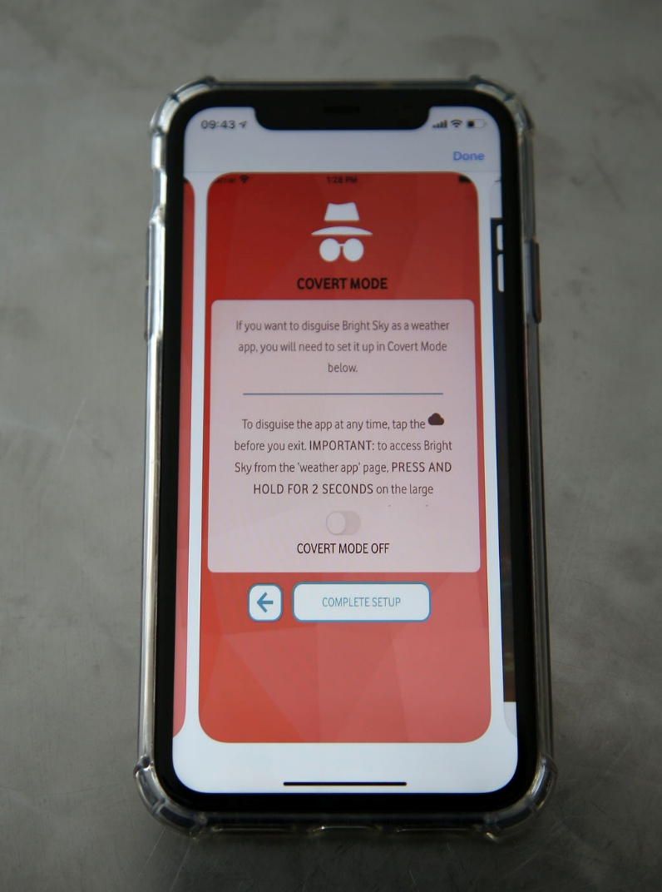

Figure 1: Bright Sky SA Covert Mode screen

Features that we would like to incorporate into our system:

* Users are not subject to data costs when using the app due to the zero-rated feature.
* Privacy of personal user information.
* The dedicated support and resources section provided for the user.
* ‘Covert’ mode – allowing users to stay anonymous.

Features that we would like to avoid:

* This app is not designed for emergency situations. We would like to have this option for users who find themselves in a dangerous situation.
* It acts more as an information hub than a direct reporting tool. Sometimes an abundance of information and resources can be overwhelming for users – we would like to have a balance of both an information and reporting section.
* The app does not act as a direct channel to authorities such as police and NGOs. It shows the user where they can find help near them, but we would like users to have that direct access to help services.

GRIT (Gender Rights in Tech) is an Android and iOS application that provides a secure and confidential way for survivors to report a GBV crime, as well as allowing them to have access to support services. It contains a panic button, a database that can store up to ten years of evidence, and a chatbot (as seen in Figure 2) that aids victims in speaking about their situations without fear of stigma, allowing them to gain some useful legal and health advice.

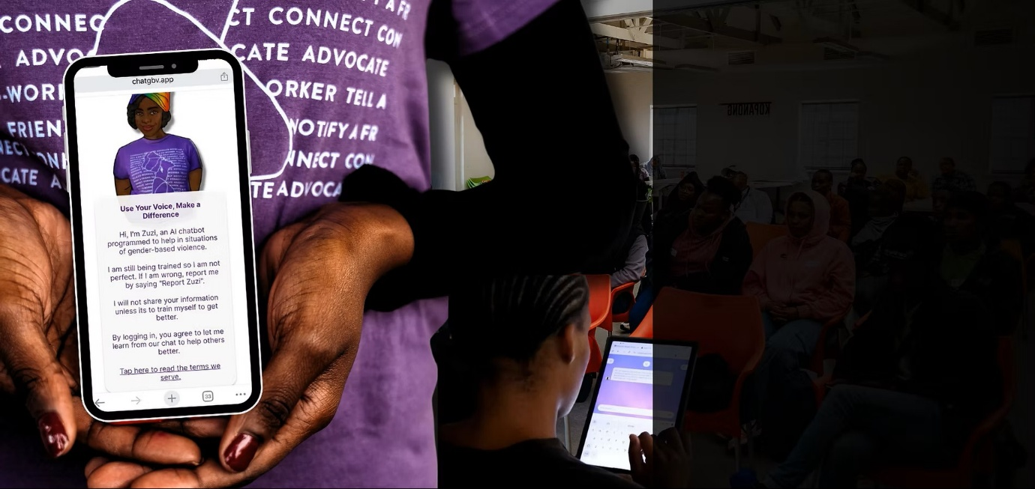

Figure 2: GRIT Chatbot Screen

Features that we would like to incorporate into our system:

* The panic button for immediate location tracking and emergency response.
* Ability of long-term storage in a secure manner.
* Accessibility through the ‘no cost’ approach in regard to the app and data usage

Features that we would like to avoid:

* The use of a centralised vault for evidence storage. It would be beneficial for the user to store evidence on their local device.
* High dependency on emergency armed response. Our aim is to provide a more inclusive approach for users to either contact emergency services or their trusted contacts.

Namola is accessible to mobile Android as well as Apple users and provides instantaneous access to emergency services. The press of a button will enable the user to access services such as the police, fire department, ambulance, and traffic officers. This application ensures a quick and reliable outcome for those who find themselves in a crisis. It does not only specialise in GBV, but many other situational incidents – such as fires, wellbeing, and safety. Figure 3 shows the community screen included in the Namola application, allowing for users to stay updated on any reports or incidents in and around their city.

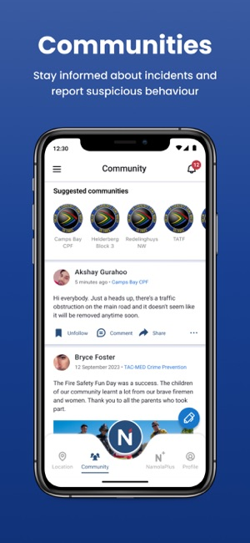

Figure 3: Community screen on Namola

Features that we would like to incorporate into our system:

* Sharing user location to emergency services
* SOS button for immediate response from emergency services
* ‘Sensitive Mode’ which allow users to stay anonymous in their reports.

Features that we would like to avoid:

* The broad emergency response rather than focusing on GBV crimes does not align with the goals of our application.
* Namola Plus, a paid subscription which provides private armed response, limits the accessibility that we are aiming to achieve with our application.
* The spotlight on armed response, with no access to NGO support, can result in a GBV survivor feeling as if they cannot report their situation in a safe and discreet manner.

**1.5 The project plan**

A project, or project management plan is a document that contains a project scope and objective. Typically, it will be represented as a Gannt chart to make it easy to convey information.

A project plan should answer these questions:

* What are we delivering?
* How will we deliver on time?
* Who is working on the project and in what role?
* What miles stones/goals are set for project?

Before you can start your project plan you need to understand (at a minimum) the following things:

* What does your client expect/need?
* The goals of the project
* What is the decision-making process of your client, and how will they approve and review the project work?
* Who is the sponsor?
* Who is the project manager?
* What other stakeholders are important?

As project manager you also need clarity from your client to know exactly what their expectations are. Sometimes this requires you to ask some hard questions to get a clear understanding.

Questions that may impact a project plan:

* How will you collect feedback?
* Who has the final sign-off?
* What is the project deadline?
* What is the availability of the project team?
* How often will the teams meet for feedback?
* Does your team have a history of successful projects?
* What can prevent the project from being a success?
* What tools and methods of communication will the team use?

*Your project plan should include the following information (at the very minimum):*

* *Project and client name (make one up)*
* *Delivery date and version*
* *Milestones and deliverables*
* *Clear task durations with start and end dates (using a Gantt chart)*
* *Dependencies for tasks (i.e., should anything happen before this task can happen).*

**1.6 Risk Analysis**

During the process of brainstorming our app, we have found potential risks that would affect the app and those who use it. When risks are identified, it would then need to be decided how those risks will be handled. Therefore, it is important that we identify some of these risks to ensure it is easier for us to determine which risks are preventable or are of higher importance. These risks can be divided in four categories:

**Acceptable risks:** Fake reports would fall under this category as it would be too costly and resource-heavy to fully prevent them and would possibly deter genuine users from using the app. Overall, it would be more beneficial to accept that there will be a few fake reports which would be outweighed by the genuine ones.

**Avoidable risks:** Loss of data is an avoidable risk due to the preventable actions that can be taken such as ensuring backups are frequently occurring and stored in multiple locations securely. Another risk could be the lack of awareness of our app, which can be avoided by implementing awareness drives where communities know more about it.

**Minimizable risks:** Although privacy violations are not completely avoidable, there are steps that can be taken to minimize the impact or occurrence of them. Using encryption and secure authentication can reduce privacy violations and protect the confidentiality and integrity of user data.

**Transferable risks:** In the context of our GBV app, a big transferable risk would be the legal or compliance issues. Instead of having an incident where we would break the law or have an oversight, we would rather transfer that responsibility to NGOs and or legal advisors who have the expertise to manage it in a professional manner.

**1.7**

# References

Almeida, T., Santos, C., & & Monteiro, J. (2021). Encryption and anonymity in sensitive data reporting systems: A case study on gender-based violence. *Proceedings of the 14th International Conference on Theory and Practice of Electronic Governance*, (pp. 312–321).

Artz, L., Smythe, D., & Williams, C. (2016). The police response to gender-based violence in South Africa: A review of the literature. *Gender & Society*, 247–274.

Gqola, P. D. (2015). *Rape: A South African nightmare.* Johannesburg, South Africa: MFBooks.

GRIT. (n.d.). *Our Tech*. Retrieved from Grit GBV: https://www.grit-gbv.org/technology

GSMA. (2021). *Mobile Economy Sub-Saharan Africa*. Retrieved from GSM Association: https://www.gsma.com/mobileeconomy/wp-content/uploads/2021/09/GSMA_ME_SSA_2021_English_Web_Singles.pdf

Lyndon Julius. (2024, July 31). *GRIT introduces AI chatbot to UCT staff and students*. Retrieved from UCT News: https://www.news.uct.ac.za/article/-2024-07-31-grit-introduces-ai-chatbot-to-uct-staff-and-students?utm_source=chatgpt.com

Machisa, M., Jewkes, R., Lowe-Morna, C., & Rama, K. (2016). *The war at home: The gender based violence study.* Johannesburg, South Africa: Gender Links.

Meier, P. (2015). *Digital humanitarians: How big data is changing the face of humanitarian response.* CRC Press.

Mkhize, S. (2020). Barriers to reporting gender-based violence in rural KwaZulu-Natal. *South African Journal of Psychology*, 290–302.

N.A. (2020, November 30). *Everyday Heroes: Fighting against violence*. Retrieved from Victim Empowerment Programme: https://gbv.org.za/bright-sky-sa/

Naeemah Abrahams, S. M. (2013, April 2). *Intimate Partner Femicide in South Africa in 1999 and 2009*. Retrieved from PLOS Medicine: https://doi.org/10.1371/journal.pmed.1001412

Namola. (n.d.). *Namola Safety App*. Retrieved from Namola: https://www.namola.com/

Office, U. P. (2021). *US Patent No. US 10,936,102.*

SaferSpaces. (2020). *Understanding and preventing violence in South Africa*. Retrieved from SaferSpaces: https://www.saferspaces.org.za

Semaan, B., Britton, L., & Dosono, B. (2020). Transitional resilience and technology: A review of the Circle of 6 app. *Proceedings of the 2020 CHI Conference on Human Factors in Computing Systems*, (pp. 1–13).

South African Police Service (SAPS). (2022). *Crime statistics: Republic of South Africa: Fourth quarter 2021/2022*. Retrieved from SAPS: https://www.saps.gov.za

Vetten, L. (2019). *Justice for survivors of sexual violence in South Africa: A review of the law and the evidence.* Tshwaranang Legal Advocacy Centre.

Vodacom. (n.d.). *Popular Pages*. Retrieved from Vodacom zero-rates Bright Sky SA gender-based violence awareness app | Vodacom Group: https://www.vodacom.com/news-article.php?articleID=7594#:~:text=JOHANNESBURG%20%2D%20As%20part%20of%20its,services%20such%20as%20Bright%20Sky.

Women’s Tech Network. (2022). *Safety tech and design: Best practices for DV apps*. Retrieved from Women’s Tech Network: https://womentechnetwork.org/reports/safety-tech-design

World Health Organization. (2013). *Global and regional estimates of violence against women: Prevalence and health effects of intimate partner violence and non-partner sexual violence.* WHO.